2
1)

#include <stdio.h>
#include <stdlib.h>
#include <limits.h>

int main(void)
{
printf("\nchar:\n");
printf("Size of char: %d bits\n", CHAR_BIT);
printf("Maximum value of char: %d\n", CHAR_MAX);
printf("Minimum value of char: %d\n", CHAR_MIN);
printf("Maximum value of signed char: %d\n", SCHAR_MAX);
printf("Minimum value of signed char: %d\n", SCHAR_MIN);
printf("Maximum value of unsigned char: %u\n", UCHAR_MAX);
printf("\nint:\n");
printf("Maximum value of int: %d\n", INT_MAX);
printf("Minimum value of int: %d\n", INT_MIN);
printf("Maximum value of unsigned int: %u\n", UINT_MAX);
printf("\nlong:\n");
printf("Maximum value of long: %ld\n", LONG_MAX);
printf("Minimum value of long: %ld\n", LONG_MIN);
printf("Maximum value of unsigned long: %lu\n", ULONG_MAX);
printf("\nshort:\n");
printf("Maximum value of short: %d\n", SHRT_MAX);
printf("Minimum value of short: %d\n", SHRT_MIN);
printf("Maximum value of unsigned short: %u\n", USHRT_MAX);
return EXIT_SUCCESS;
}
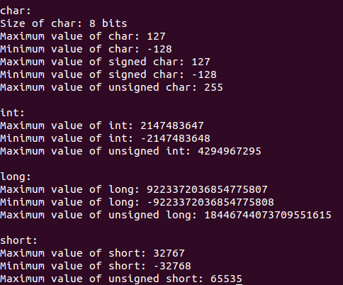

2)
#include <stdio.h>
int main(int argc, char const *argv[])
{
int len,max,c,lim=10;
char line[100],maxline[100],s[100];

max =0;
for(int i=0; i < lim ;++i) {
c = getchar();
// if (c == EOF)
// break;
if (c == '\n')
break;
s[i] = c;
}
printf("\n%s\n", s);
return 0;
}
3)
#include <stdio.h>
int htoi(char s[])
{
int hexdigit,i,inhex,n;
i = 0;
if( s[i] == '0')
{
++i;
if(s[i] == 'x' || s[i] == 'X')
++i;
}

n = 0;
inhex = 1;

for(;inhex==1;++i)
{
if(s[i] >='0' && s[i] <='9')
hexdigit= s[i] - '0';
else if(s[i] >='a' && s[i] <='f')
hexdigit= s[i] -'a' + 10;
else if(s[i] >='A' && s[i] <='F')
hexdigit= s[i] -'A' + 10;
else
inhex = 0;

if(inhex == 1)
n = 16 * n + hexdigit;
}
return n;
}

int main(int argc, char const *argv[])
{
char a[2];
scanf("%s",a);
// a[0]='2';
// a[1]='0';
printf("%d\n",htoi(a) );
return 0;
}
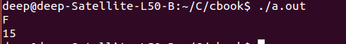

4)
#include <stdio.h>
char s[100]={"deep shah"};
void squeeze(char *s1, char *c)
{
printf("%s\n",s1);
printf("%s\n", c);
int i=0,j=0;
char a[100];
while(s1[i]!='\0')
{
if(s1[i]!=c[0])
{
a[j]=s1[i];
j++;
}
i++;
}
a[j]='\0';
printf("output:%s\n",a );
}
int main(int argc, char const *argv[])
{

//printf("%s\n",s );
char c1[1];
printf("enter character:\n");
scanf("%s",c1);
//printf("%s\n",s );
squeeze(s,c1);

return 0;
}
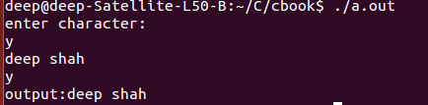

5)
#include <stdio.h>
char a[100],b[100];
int any(char *a1,char *b1)
{
int flag=0,index=0;
for (int i = 0; b1[i]!='\0'; ++i)
{
for (int j = 0; a1[j]!='\0'; ++j)
{
if(a1[j]==b1[i])
{
index=j;
flag=1;
break;
}
}
}
if(flag==1)
{
return index;
}
else
{
return -1;
}
}
int main(int argc, char const *argv[])
{
printf("enter string:\n");
scanf("%s",a);
printf("enter character:\n");
scanf("%s",b);
//printf("%s%s\n",a,b );
int aaa=any(a,b);
printf("%d\n", aaa);
return 0;
}
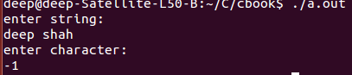

6)
#include<stdio.h>

unsigned setbits(unsigned x,int p,int n,unsigned y);

int main(void)
{
printf("%u\n",setbits((unsigned)12,3,2,(unsigned)57));
}

unsigned setbits(unsigned x,int p,int n,unsigned y)
{
return x & ~(~(~0 << n) << (p+1-n)) | ( y & ~(~0<<n)) << (p+1-n);
}
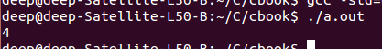

7)
#include<stdio.h>

unsigned invert(unsigned x,int p,int n);

int main(void)
{
printf("%u\n",(unsigned)invert((unsigned)8,(int)3,(int)3));
}

unsigned invert(unsigned x, int p, int n)
{
return x ^ (~(~0 << n) << (p + 1 - n));
}

8)

#include<stdio.h>

unsigned rightrot(unsigned x,int n);

int main(void)
{
printf("%u\n",(unsigned)rightrot((unsigned)8,(int)1));

return 0;
}

/* rightrot: rotate x to right by n bit positions */

unsigned rightrot(unsigned x,int n)
{
int wordlength(void);
unsigned rbit;/* rightmost bit */

rbit = x << (wordlength() - n);
x = x >> n;
x = x | rbit;

return x;
}

int wordlength(void)
{
int i;
unsigned v = (unsigned) ~0;

for(i=1;(v=v>>1)>0;i++)
;
return i;
}

9)
#include<stdio.h>

int bitcount(unsigned x);

int main(void)
{
printf("%d\n",bitcount((unsigned)12));
}

int bitcount(unsigned x)
{
int b;

for(b=0; x!=0; x &= x-1)
++b;

return b;
}

10.
#include<stdio.h>

int lower(int c);

int main(void)
{
int c;

while((c=getchar())!=EOF)
{
putchar(lower(c));
}
}

int lower(int c)
{
return c>='A' && c<='Z'? c+'a'-'A':c;
}
